Walk Plan for 17 Aug 2026 Stoke Ferry rivers

[Describing the guided walk]: Explore Stoke Ferry’s fascinating waterways history with guided walk through countryside and historic High Street, ending with refreshments. Our walk will take us on a country lane to the common and along the Cut Off Channel and river Wissey, returning through the historic High Street. We will hear some stories of recreation in the channel and of navigation and fun on the river, and hear how and why the new channel was built. We will immerse ourselves in the sights and sounds of the rivers and countryside, finishing with tea and coffee and a chance to chat. The walk is just over 2.6 miles/4.2 km, and is suitable for all ages, and is mostly accessible, along pavements and firm paths, though some sections could be narrow or uneven.

This walk was organised jointly with Stoke Ferry walkers – who welcome all to their regular walks every Monday meeting 945 and setting off 10:00 am – and return afterwards to the pavilion for refreshments (tea, coffee and cake for a suggested donation of £3).

Organised and led by @OSBrecks (https://osbrecks.co.uk/), jointly with Stoke Ferry Walkers (on Facebook: Stoke Ferry Walkers, https://www.facebook.com/profile.php?id=100082032200765 )

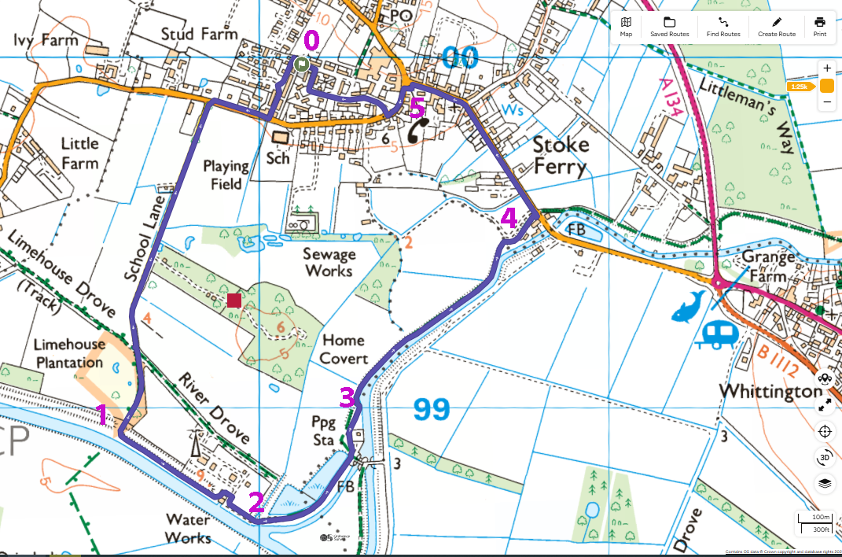

The walk 17 August was part of the Brecks Outdoor Festival 2026 (8-23 August), supported by National Heritage Lottery Fund. The Brecks team with grant funding to April 2027 will build on over a decade of successful collaboration to put together a new, long-term Brecks Landscape Partnership (BLP for short), uniting communities, landowners, conservation bodies, and local authorities to protect and enhance the Brecks. It will include heritage, conservation, and engaging people in activities outdoors in the Brecks and fen edge. See brecks.org

Several planned stops where there is space for us to stop and talk about some of the interesting history along the way, and we hope to give a sense of the environment, the waterways and the village.

Stoke Ferry has a rich history, once a key river crossing and road hub, now bypassed by the A134. The village is on edge of the Fens, area of waterways and agricultural land. By the Norman Conquest, it was already well-established and appears in the Domesday Book of 1086. From the mid-18th to late 19th century it grew into a bustling market town thanks to its strategic location on the river and key roads. And we will see two key waterways that shaped the area.

We will walk down to Wretton Road, turn right, walk along and then turn left down School Lane to the common. Safety note: vans and other vehicles come along here. Back marker will warn and we will step off onto the most suitable verge (left or right)
When we turn left, have a look at the buildings on your right – these were the old school. And halfway down School Lane, look at the cottage – if you don’t already know we will explain its history later.

Once we reach the common we will stop there next to the Cut Off Channel [overlooking the channel]
1. At Stoke Ferry Common

First: the architecture of the cottage on School Lane and the bump in the road show that it was originally connected with the railway line that crossed the land there. Closed in the 1960s – we will pass the site which is now being redeveloped and say more then.

Stories from common and the coming of the Cut Off Channel: extracts from memories:

1983 account by Doris E Coates, who came to live in the village in 1953, and taught in village school.
“I remember how attractive the Common was then, before the construction of the "New Cut" … and before the building of the Anglian Water Authority's premises.…
“On the Common itself were three ponds, one of which was very large and fringed with bulrushes and yellow irises. It was a great place for finding frog-spawn. Beyond this was a beautiful large wood, of which only a fragment remains. Early in the year it was carpeted with double and single snowdrops. Later there were great expanses of bluebells, and many primroses and violets. I was never without posies of wild flowers gathered by the children who loved to explore this delightful spot”.
[old photos of school and more from her son, https://www.facebook.com/HarpsdenPress ]

“I recall my stepfather, who grew up in Wretton, talking about swimming in ponds at the Common when he was a lad. I think he said there were 3 ponds. When I was young, with other youngsters, we would walk to a wood further along School Drove to gather snowdrops. Then came the Cut-Off channel which probably caused the ponds to drain away..
Later, as a young teenager, I used to go plum picking during the summer school holidays at a fruit farm which had orchards either side of the Cut-Off channel. A friend and I would go swimming in the Cut-Off channel hot after fruit picking. It was then clear and deep and the banks were not really overgrown.… The ‘beaches’ along the Cut-Off channel were – and I think still are – regular places where people would go [to swim] because there was some sand exposed. I took my son and his cousins there regularly in the 1980s. And the part nearest to the Common was so used and the bank eroded so that you could nearly walk across to the other side.” Helaine Wyett 2024

When Alexis and her friends swam in the Cut Off Channel, the water was blue and there were no weeds – it was barren. It was shallow on the edges near the bank, and Alexis and her boyfriend Keith (now husband) would go along with her brother Jack and his girlfriend Christine (now sister-in-law). [Photos 2 July 1967, when aged 15]

“We'd often go down there when we were younger. We wouldn't tell our mums and dads….
“ We'd call them the beach and they're still called the beach. And the kids, my son, who's nearly 50, he said he had the best childhood ever in Stoke Ferry ...we walked the riverbank not so long ago. And I said, "What did you used to do down here, Tom?" He said, "You don't really want to know.” [Laughter]. So, they just had lots of fun. The kids have always had fun down there.”
Alexis Brand, oral history interview, 2024

Also memories of driving a car along it when it was frozen solid probably 1963. And skating along it.

Nowadays this is a popular place to come to walk and for some to swim. We’ll hear more about the Cut Off Channel shortly. The process was considered urgent in the mid-1950s, and it cut through the common and several public rights of way, some of which are now closed off and blocked despite legislation protecting them for public access.

Next we will walk on along the lower path, round the waterworks and round to the left beside the Cut Off Channel. Stop by the bench.

2. Overlooking the Cut Off Channel
Cut Off Channel 1954-64 – sliced through land, paths and existing waterways along its length, including the Lakenheath Lodes which had outlived their usefulness as drainage channels and transport system.
Fens drained over several centuries, but still flooding, including in the 1930s. After delays caused by the Second World War, the major 1947 floods gave impetus to construction of three flood relief schemes beginning in 1954, finished by 1964. This one, Great Ouse Relief channel and Bedford.
At about the same time, there were water supply problems in Essex. By 1968 a scheme was devised to reverse the flow on the Cut-off Channel in summer. Water is fed into the channel by the sluice at Denver, and flows southwards to Blackdyke Intake where the water descends 90 feet down a shaft to a tunnel, then to a Pumping Station which raises the water 280 feet to the surface, from where pipelines take it to a tributary of the River Stour, to be extracted from the river system further downstream for pumping to Abberton or Hanningfield Reservoirs. Known as the Ely-Ouse to Essex Water Transfer Scheme. (Keith Brand worked on this scheme – a big undertaking.) In winter the Cut Off Channel takes flood water from the rivers Lark, Little Ouse and Wissey to Denver sluice and the Great Ouse and from there to the sea. So water flows in different directions depending on the time of year.

Alexis, her family and other farmers and local people were aware of the need for the channel, having suffered floods especially in 1947. And there hasn’t been flooding since it was dug. “… my mum said...well before all this happened, she said, this is really important, she said, because in 1947 when they were living down in Poultry Farm, the water, the flood water came up to the window sills.”

Others were less happy, including an interviewee at Lakenheath (Cyril Matthews), where the Lode that had been enjoyed for walking, swimming, fishing, earlier for navigation, destroyed by new cut.
“I can't remember learning to swim, but it was in a sandy part of the Lode, not far from the Hythe…I suspect that my elder brother said, “Go on, get in, boy” and that was that. So …that was my first introduction to water.” But once the Cut Off Channel came along no one was allowed to go near it and “… the village lost the means of youngsters learning the art of swimming and fishing.”

A detailed account of creating it was provided to Alexis by one of the digger drivers, Don Wyatt. It includes technical detail about the huge buckets – 5 cubic yards – a lorry load, and the base of the machine is 21 feet. Alexis’ father has done a cine film of this in action (available my website – link).
Read account of digging the new cut from driver, Don Wyatt (link downloads Word.docx, 1 page)

Alexis and her friends and family would go and watch after school:
“It was fun. And they weren't drag lines that were on crawler tracks. They were like on legs ... a walking machine. Incredible. And there were two and they did 12-hour shifts, 12 on, 12 off [non stop excavation, all the way from Denver to Barton Mills – 28 miles (45 km)!].

Just along from here you can see the aqueduct where the Wissey flows in a channel above the Cut Off Channel. And here there are channels linking them and with the Anglian Water premises. The film we can see after the walk will make this all much clearer and give more info.

Images/documents/film:
- https://stokeferrydhg.org/the-river-wissey-from-the-air-all-the-way-from-hilgay-to-stoke-ferry/ – aerial film with narration by Roger Warner
- Map showing Key rivers and drains in Fens and Brecks
- Wikipedia diagram of the Cut Off Channel entire length
- 1884 OS map and current OS map: Common and river and Cut Off Channel
https://maps.nls.uk/geo/explore/side-by-side/#zoom=16.0&lat=52.56356&lon=0.50358&layers=257&right=OSLeisure
- Document with summary of detailed account [print], https://osbrecks.co.uk/wp-content/uploads/2026/10/ELY-DRY-ESSEX-WET-cut-off-channel-synopsis-2.doc. By Chris Holley, 2005 (who has also produced a 92 page document)
- Digging the Cut Off Channel – still from cine film made by Alexis’s father, Jeff Waterfall, available on OSBrecks.co.uk website (can send link, or search for cine films). Digging out the ‘New Cut’ near Wissington Sugar Beet Factory, (?) 1963 [7]

Continue on round to join the path alongside the river Wissey

3. By the river Wissey (Stoke Ferry/Wissey) beach

Popular swimming place in the river Wissey for local people, families, young people having picnics, some bring canoes/paddle boards, and touring motorboats pass by. A shady tree with rope swings…
[what is the popular name for the place nowadays – does anyone know?]

1983 account by Doris E Coates: [In the 1960s/70s?] “…the River Wissey flowed, sparkling clear, rich in fish and excellent water-cress, in the shadow of willows and wild roses. Several times I saw a kingfisher at this spot. My husband taught Richard and I to canoe on this bit of river. Sometimes we hauled our small sailing dinghy down …and sailed down the Wissey to the point where it joins the River Ouse, then on to Denver Sluice.
On one such trip we had a surprising experience. It was during a rare heat wave, and we had noticed cattle from surrounding land standing with their feet in the river to keep cool, but it was startling to hear loud splashing behind us and to see a cow swimming purposefully down the middle of the river. We quickly pulled into the bank for safety, and watched it pass and disappear round the next bend and out of sight, with all the determination of a Channel swimmer.”
[https://www.stokeferry.com/2018/03/meet-richard-coates/ ]
(Also mentioned by Helaine Wyett as a popular place for swimming and picnics, referring to 1980s)

Back up the bank – shortcut or longer easier route. Turn right and continue along beside the river on the bank, look towards the bridge, go through the gate into the footpath and stop by the wire fence, where you can see through to the old station.

Before Stoke Ferry Bridge – industries and the railway and station

The river Wissey links to the Great Ouse and from there to King’s Lynn and the sea, and was important for navigation, trade and industry. Stoke Ferry was an important crossing point, and had industrial buildings, including maltings at Whittington, and at Stoke Ferry a mill complex, wharves and the riverside Bull Inn. 1865 description of Stoke Ferry: “considerable business is done at the Wharf in corn, coals, malt, flour, &c.”

The steam driven flour mill was on the opposite side of the bridge (Whittington), owned and run by Jacob Mason Bird 1848-90, miller here and at Downham Market, had access to grain and coal from King’s Lynn, but also saw advantages of the new steam railway. In March 1865 Jacob gave evidence to a House of Commons Committee on the railway, as a miller at Whittington and Downham. “The corn consumed at Whittington Mill averages 12 tonnes a week. I get it from Lynn by the Ouse and the Wissey. … The railway would undoubtedly be of great benefit … I believe the [new] line would save me £500 a year … Sometimes my mill stops because I cannot get corn in consequence of the deficiency of water in the river.”
https://stokeferrydhg.org/birds-mill-1848-90-whittington-road-stoke-ferry-bridge/

The Station:
“My memories of Stoke Ferry as a little girl in the early 1900s…have not faded over the years. I recall with great excitement at being taken to the station to see the train, and we were entertained by the train driver, Uncle Joe, blowing the whistle, letting off a cloud of steam. The station master was so kind to us. Mr English was his name my mother reminded us. …This treat would not have been complete without a visit to the nearby Mill House and the old mill to have tea with Granny Wright who lived in the House. The old mill and the house have been demolished alas…”
Isabella Burbeck (Mrs), nee Lake, article in the Village Pump November 1979:
https://stokeferrydhg.org/within-living-memory-looking-back-at-our-history-exhibition-in-may-2024/

In 1938 Harry Oswald Crouch (HO) bought 2,500 acres along the river Wissey, the derelict mill, cottages and farm buildings, and developed the Crouch (Dehydration) Plant. This was a large operation until the late 1980s and you can just see a few remnants today on the road towards Whittington, and the office building in the railway station area.
https://stokeferrydhg.org/a-history-of-crouch-dehyrators-limited-stoke-ferry/

Nowadays all the industrial buildings have gone or been converted into houses, and the river is more used for pleasure boating, with moorings for residents and passing traffic at nearby Whittington, where also there is a campsite and paddle boat launching for a small fee. (GOBA mooring here)

The Mayflower houseboat:
1954 newspaper article: “Make a houseboat your home
Capt. Crosse ...who celeb dear rates his ninetieth birthday next Sunday lives in a comfortable houseboat moored at one of the most picturesque spots on the River Wissey at Stoke Ferry.
"I have electric light and a gas stove where I can prepare my tea, and I have my main meals sent in from a nearby hotel. I have not known such trouble-free comfort and good health for years," he said.
As to his future plans he said, “So far as is known Stoke Ferry has never yet had a centenarian, and it is my little ambition to live to be a hundred years of age.” ”
[Photos of houseboat, the captain/whole article, of the bridge and Bull Inn and wharves]

Turn left along Bridge Road – look again at the development on your left where the railway station was, see the new and old buildings.

…and continue on the pavement and along the High Street. It isn’t possible to cover everything about the High Street. Stoke Ferry & District History Group have done lots of research and collecting of memories and photographs – see their website https://stokeferrydhg.org/within-living-memory-looking-back-at-our-history-exhibition-in-may-2024/, and many more.

Memories/information about the High Street shops
“Another wonderful memory was a visit to Mr. Harold, the photographer opposite the station. The camera was a very new invention in those days. We were to have our photos taken to send to our grandparents in Scotland. This was a very wearying job. Mr. Harold kept disappearing under a black cloth showing us to ‘Watch for the birdie.’ I still treasure the photos, taken by this Stoke Ferry photographer of the 1900s onwards.
“The shops, seem to have provided me with most of my memories. …
Isabella Burbeck (Mrs), nee Lake, article in the Village Pump November 1979
https://stokeferrydhg.org/within-living-memory-looking-back-at-our-history-exhibition-in-may-2024/

Harry William Harold (1863-31st December 1939) was a professional photographer. He lived and had a shop and garden studio at Number 1, Bridge Road, Stoke Ferry from c1885 – c1935.
During this period of commercial activity, Harry W Harold produced photos of individual people and scenes of daily life in Stoke Ferry, nearby villages, and the surrounding countryside. At his studio, Harry took portraits of local people – as just described!
https://stokeferrydhg.org/harry-william-harold-photographer-no1-bridge-road-stoke-ferry-west-norfolk/

Moulsham House – various uses as shops since it was built at the end of the 18th century, including a small department shop, and from the early 20th century and at least until the 1960s part was a part-time Barclays bank, also in the 1950s/60s an electricity board representative was there to take quarterly payments – very different life in villages even that recently – memories Alexis, Helaine
https://stokeferrydhg.org/a-history-of-moulsham-house-high-street-stoke-ferry/–

We will turn left into Wretton Road and stop in the car park.

5. Opposite the old Duke’s Head pub
1794, Grade II listed, closed 1975 and reopened as the Millers Arms Social Club and canteen for Favor Parker staff, then closed in 1996. Now being redeveloped into housing. [1940s image]
https://stokeferrydhg.org/the-dukes-head-the-hill-stoke-ferry/
We will continue along Wretton Road, then turn right into Buckenham Drive to return to our starting point, where we will have a quick roundup and refreshments and the chance to watch a short film.

After the 17 August walk Jim McNeill from the Stoke Ferry and District Local History Society kindly brought along a film showing from the air the route we took and how the rivers and other waterways fit together, with a really interesting narration from local resident and historian Roger Warner who has lived here all his life. We also have some cine film of the Cut Off Channel being dug. See links below.

Links:
Stoke Ferry & District History Group https://stokeferrydhg.org/

Stoke Ferry Walkers, on Facebook, https://www.facebook.com/p/Stoke-Ferry-Walkers-100082032200765/

1884 OS maps showing whole walk then and now
https://maps.nls.uk/geo/explore/side-by-side/#zoom=16.0&lat=52.56444&lon=0.50457&layers=257&right=OSLeisure

1964 OS and Land utilisation
https://maps.nls.uk/geo/explore/side-by-side/#zoom=16.0&lat=52.56524&lon=0.51438&layers=282&right=OSLeisure

Aerial film of the river Wissey, commentary by Roger Warner
https://stokeferrydhg.org/the-river-wissey-from-the-air-all-the-way-from-hilgay-to-stoke-ferry/

OH and CINE OSBrecks
https://osbrecks.co.uk/cine-films/ ; https://osbrecks.co.uk/oral-history/

Fens floods films

During https://www.facebook.com/reel/855512413928457 [still shows water and house]
https://www.facebook.com/reel/855889053841518
(after) https://www.facebook.com/reel/1685513012731138
And https://www.facebook.com/reel/2247239812757535
From
https://www.facebook.com/FenlandOnFilm/reels/

See images: https://osbrecks.co.uk/historic-images-gallery-stoke-ferry-walk-2026/

